Task 3 – Cyber Threat Identification
Intern: Amruta | Track: Cyber Security | Level 1 · Day 3 | Organization: Veda Technology

Objective
To recognize common cybersecurity threats, understand who they target, what damage they cause, and how to prevent them.

Tools Used
- Browser
- Google Docs

Threat Classification Table
Threat | Description | Target | Impact | Prevention
Phishing | Fraudulent emails, messages or websites that imitate trusted entities to trick people into revealing sensitive information or clicking malicious links. | Email users, employees, bank customers | Stolen credentials, financial loss, malware infection, data breach | Verify sender and URLs, avoid unknown links and attachments, use spam filters, enable multi-factor authentication (MFA), run awareness training
Malware | Malicious software such as viruses, worms, trojans, spyware and adware designed to damage, disrupt or gain unauthorized access to systems. | Computers, servers, mobile devices, networks | Data theft or corruption, system slowdown or crash, loss of privacy, remote control of devices | Install and update antivirus, patch OS and software, download only from trusted sources, restrict admin rights, back up data
Ransomware | A type of malware that encrypts a victim's files and demands payment (ransom) for the decryption key. | Businesses, hospitals, schools, government bodies, individuals | Loss of data access, operational downtime, financial loss, reputational damage, possible data leak | Regular offline backups, keep systems patched, email filtering, network segmentation, endpoint protection, incident response plan
Social Engineering | Psychological manipulation of people into giving up confidential information or performing unsafe actions (e.g., pretexting, baiting, vishing, tailgating). | Employees, help-desk staff, general users | Unauthorized access, leaked confidential data, fraud, security policy bypass | Security awareness training, verify identity before sharing information, follow access-control policies, report suspicious requests
Credential Theft | Stealing usernames and passwords through keyloggers, phishing, brute force, credential stuffing or data breaches. | User accounts, admin accounts, online services | Account takeover, identity theft, unauthorized transactions, lateral movement inside networks | Use strong unique passwords and a password manager, enable MFA, monitor for breaches, avoid password reuse, lock out after failed attempts

Interview Questions

1. What is phishing?
Phishing is a cyber attack in which an attacker poses as a trusted person or organization, usually through email, SMS or a fake website, to trick the victim into sharing sensitive data such as passwords, card numbers or OTPs, or into installing malware. Variants include spear phishing (targeted), whaling (aimed at executives), smishing (SMS) and vishing (voice calls).
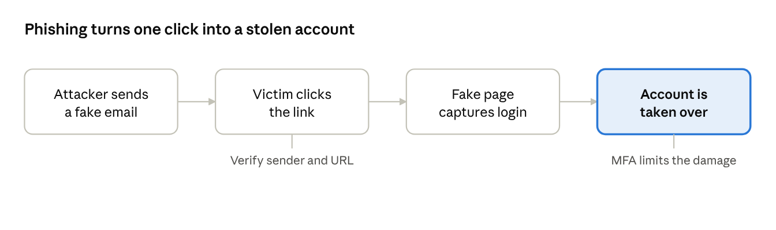
phishing attack flow · 4 steps

2. What is ransomware?
Ransomware is malicious software that encrypts a victim's files or locks their system and demands a ransom, typically in cryptocurrency, in exchange for restoring access. It commonly spreads through phishing emails, malicious downloads or unpatched vulnerabilities. The best defenses are regular offline backups, timely patching and user awareness.
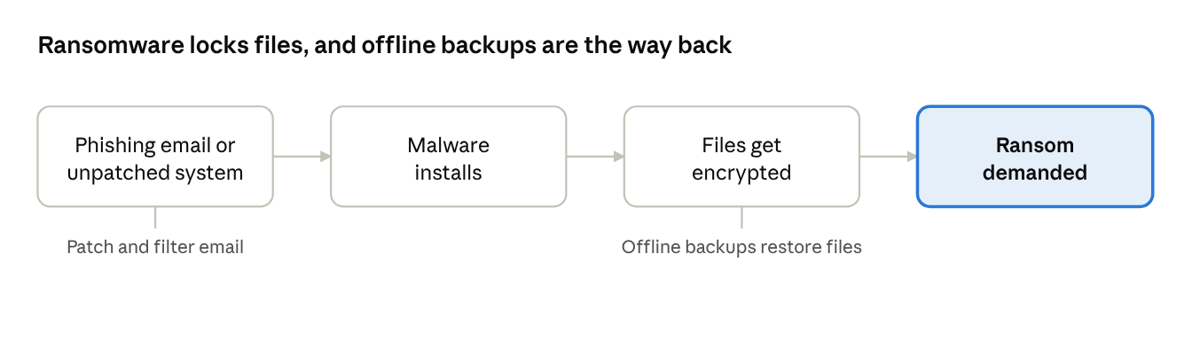
ransomware attack flow · 4 steps

3. What is social engineering?
Social engineering is the practice of manipulating human psychology, using trust, fear, urgency or curiosity, to make people reveal confidential information or take actions that compromise security. It targets the human element rather than technical flaws. Examples include pretexting, baiting, tailgating and impersonation calls.

Conclusion
Phishing, malware, ransomware, social engineering and credential theft are among the most common threats to individuals and organizations. Many of them overlap, for example a phishing email can deliver ransomware or steal credentials. A layered defense of technical controls (updates, antivirus, MFA, backups) combined with user awareness significantly reduces risk.

